**PROJECT ON**

**TOURIST RECOMMENDATION SYSTEM**

**BACHELOR OF TECHNOLOGY**

**in**

**COMPUTER SCIENCE AND ENGINEERING**

**Submitted by:**

AMAAN KHAN (11805050) 41

SYED OMAR (11805045) 38

ANUKUL SINGH (11805001) 37

SHIVAM TIWARI (11804967) 39

**Section: K18JF**



**School of Computer Science and Engineering**

Lovely Professional University

Phagwara, Punjab (India)

**SUBMITTED TO:**

DIPEN SAINI

AI

**1@EXECUTIVE@SUMMARY**



An@expert@system@focusing@on@the@tourism@domain@will@capture@consumer@travel@interests@and@suggests@a@suitable@itinerary.@User’s@travel@and@persona@characteristics@are@prime@factors@considered@to@recommend@places@which@suits@them.@The@heart@of@such@expert@systems@is@the@knowledge@base@as@all@the@facts@for@building@the@rules@are@contained@here.@The@knowledge@base@is@the@resultant@of@knowledge@acquisition,@knowledge@representation@and@knowledge@implementation@phases.@The@source@for@knowledge@acquisition@on@tourism@domain@was@gathered@primarily@in@the@form@of@interviews@with@Subject@Matter@Experts,@surveys@conducted,@various@sources@on@the@internet@and@public@journals@and@articles.

Our@travel@recommendation@system@is@a@rules-based@expert@system@built@in@CLIPS.@The@system@can@be@used@as@a@virtual@trip@planner,@useful@for@tourists@and@the@tourism@agencies@to@select@the@best@package@based@on@factors@like@the@preferred@budget,@places@of@interests@and@personality@of@the@individual.@We@introduce@a@unique@personality@index@on@the@basis@of@a@series@of@questions@to@provide@places@based@on@persona.@Our@system@also@generates@dynamic@number@of@recommendations@to@provide@based@on@user@selection.

**Keywords:@**knowledge@engineering,@rule@based**@**expert@system,@travel@planner,@CLIPS.

AI



**2@PROBLEM@DESCRIPTION**



In@the@modern@era,@the@tourism@applications@are@helping@the@consumers@with@information@to@facilitate@their@decision-making@process@by@giving@recommendations.@The@implicit@assumption@that@is@being@made@is@that@by@capturing@the@user@needs@and@constraints@we@can@provide@a@list@of@products@for@selection@using@knowledge@compiled@into@an@intelligent@recommender.

A@classical@recommender@system@in@travel@and@tourism@domain@would@provide@the@users@with@a@list@of@options@that@are@relevant@to@their@preferences.@With@the@presence@of@heterogeneous@place@of@interests@in@the@tourist@location@we@are@focusing@on@the@problem@of@recommending@a@list@of@packages@to@the@consumer,@where@each@option@would@provide@a@list@of@Points@of@Interest@(POIs)@e.g.@Theme@Parks,@Wildlife,@Heritage,@etc.@that@may@constitute@a@tour.@The@recommended@collection@of@POIs@would@each@have@the@corresponding@cost@and@time@associated@with@it@and@the@user@specified@maximum@total@for@the@tour.@Our@prime@goal@is@to@suggest@the@most@interesting@travel@package,@where@each@package@adheres@to@the@user@provided@budget@constraints.

**2.1@PROJECT@OBJECTIVE**

Tourism@industry@has@a@strong@role@in@contributing@towards@the@economic@development@of@the@nation.@The@tourism@receipts@for@the@second@quarter@(Q2@2017)@was@estimated@at@S$6.4@million,@which@is@a@5%@growth@over@the@same@period@last@year.@This@factor@links@the@web@and@encourages@the@user@interactions@by@travel@planning@or@sharing@their@experiences.

We@have@gone@ahead@to@exploit@this@opportunity@by@building@an@intelligent@rules-based@expert@system@that@recommends@a@tourism@itinerary@by@considering@the@consumer’s@travel@interest@and@budget@preference.@The@system@will@interact@with@the@consumer@with@a@set@of@user@friendly@questions@and@records@the@responses.@The@responses@will@then@be@used@as@facts@for@the@rules-based@engine.

Our@system@not@only@notices@the@user’s@main@needs@or@constraints@in@a@top-down@way@but@also@surveys@the@option@space@and@recommends@to@the@active@construction@of@user@preferences.@Per@the@analysis@of@the@survey@done@to@know@the@consumers@preferences,@the@certainty@factor@is@deduced,@and@the@rules@are@framed.@Based@on@the@consumer’s@input@feed@the@corresponding@rules@are@triggered@and@suitable@tourism@itineraries@are@recommended@by@the@system.

The@prime@focus@of@our@tourism@recommendation@system@in@India@is@to@achieve@the@above-mentioned@target.@To@build@an@expert@system@the@basic@criteria@is@to@form@a@knowledge@base@from@which@useful@inferences@can@be@drawn.@As@tourism@is@a@vast@industry@which@can@include@many@destinations,@we@have@limited@the@scope@of@this@project@to@India.

AI



**3@KNOWLEDGE@MODELING**



**3.1@KNOWLEDGE@ACQUISITION**

In@order@to@build@our@system,@we@need@to@model@knowledge@and@data@in@the@tourism@and@trip@planning@domain@to@know@about@the@factors@that@influence@this.

**3.2@DOCUMENTED@SOURCES**

Documented@sources@cover@the@internet,@journals@and@two@different@surveys@we@conducted.@One@captures@the@tourist@description@and@basic@requirements@and@the@other@aims@to@determine@the@tourist’s@travel@persona.

**3.3@SUBJECT@MATTER@EXPERTS**

The@knowledge@base@of@our@system@was@formed@after@having@organized@a@scheduled@interview@with@Mr.@Desmond@Sek@(Co-Founder@of@Xaltius)@and@Mr.@Felix@(Co-Founder@of@Anywhr).

**3.4@KNOWLEDGE@AND@DATA@REPRESENTATION**

Based@on@the@knowledge@gained@through@the@various@resources,@we@have@come@up@with@the@characteristics@used@to@describe@a@travel@planner.

|  |  |  |  |  |  |  |  |
| --- | --- | --- | --- | --- | --- | --- | --- |
|  | **Variable** |  |  | **Meaning** |  | **Remarks@for@Data@Modeling** |  |
|  |  |  |  |  |  |  |  |
|  | traveler_type | |  | The@type@of@traveling@group |  | 1:@Solo,@2:@Group |  |
|  |  | |  |  |  |  |  |
|  | travel_type_group | |  | The@travel@group@type |  | 1:@Family,@2:@Friends,@3:@Colleagues |  |
|  |  |  |  |  |  |  |  |
|  | travel_spend | |  | Trip@budget |  | 1:@Luxury,@2:@Upscale,@3:Mid-tier,@4: |  |
|  |  |  | Economy |  |
|  |  |  |  |  |  |  |
|  |  |  |  |  |  |  |  |
|  |  |  |  |  |  | 1:@Indian,@2:@Continental,@3:@Chinese,@4: |  |
|  | food_type | |  | Cuisine@preferred@by@the@traveler |  | Japanese,@5:@Malay,@6:@Seafood,@7: |  |
|  |  |  |  |  |  | Indiaan,@8:@Multi-cuisine |  |
|  |  | |  |  |  | |  |
|  | age_group | |  | The@average@age@of@the@traveler(s) | 1:@18-25,@2:@26-30,@3:@31-45,@4:@46-60 | |  |
|  |  | |  |  |  | |  |
|  | num_travel_days | |  | Vacation@duration | 1:@1-3@,@2:@4-7@,@3:@7-10@,@4:@11-15 | |  |
|  |  | |  |  |  |  |  |
|  | num_adults | |  | No.@of@adults@in@the@travel@group |  | Continuous@Variable,@1-10. |  |
|  |  |  |  |  |  |  |  |
|  | num_children | |  | No.@of@children@in@the@travel |  | Continuous@Variable,@0-10. |  |
|  |  | group(if@family) |  |  |
|  |  |  |  |  |  |  |
|  |  | |  |  |  |  |  |
|  | Is_kid_age_below | |  | Is@kid@below@7@years@of@age?@(< |  | Yes@or@No |  |
| _7 | |  |  | 125m) |  |  |
|  |  |  |  |  |
|  |  |  |  |  |  |  |  |

4

|  |  |  |  |  |
| --- | --- | --- | --- | --- |
|  | AI | | |  |
|  |  |  | |  |
|  |  |  |  |  |
|  |  |  | |  |
| themes | Travel@themes | 1:@sports,@2:@nature,@3:@culture,@4:@history, | |  |
| 5:@lifestyle,@6:@adventure | |  |
|  |  |  |
|  |  |  |  |  |

[Table@1@-@Knowledge@Representation]

**3.5@DATA@MODELLING**

For@determining@rules@from@survey,@we@used@association@mining@and@decision@tree@methodologies.@The@decision@tree@was@formed@using@PART@and@can@be@found@in@*j48-decision-tree-rules*@file@and@the@rules@from@JRip@can@be@found@in@*jrip-rules*

Two@aspects@of@a@customer@was@taken@into@consideration@to@decide@his/her@travel@type.@First@part@of@the@questionaire@was@dedicated@towards@the@bio@data@of@the@person@and@basic@information@about@the@trip@planned.@The@second@part@was@directed@towards@the@personality@traits@of@the@person.@For@this@we@referred@multiple@psychology@papers@and@articles.@Eight@questions@were@finalized@from@them@to@decide@the@traveler@personality.@To@find@out@the@user@personalities,@we@ran@a@survey@to@map@these@questions@to@a@given@travel@type.@We@ran@Rule@induction(JRIP)@and@decision@tree(PART)@algorithms@on@the@survey@result.@We@obtained@81@rules@to@map@the@answer@pattern@to@a@distinct@travel@type.

**3.6@DEPENDENCY@DIAGRAM**

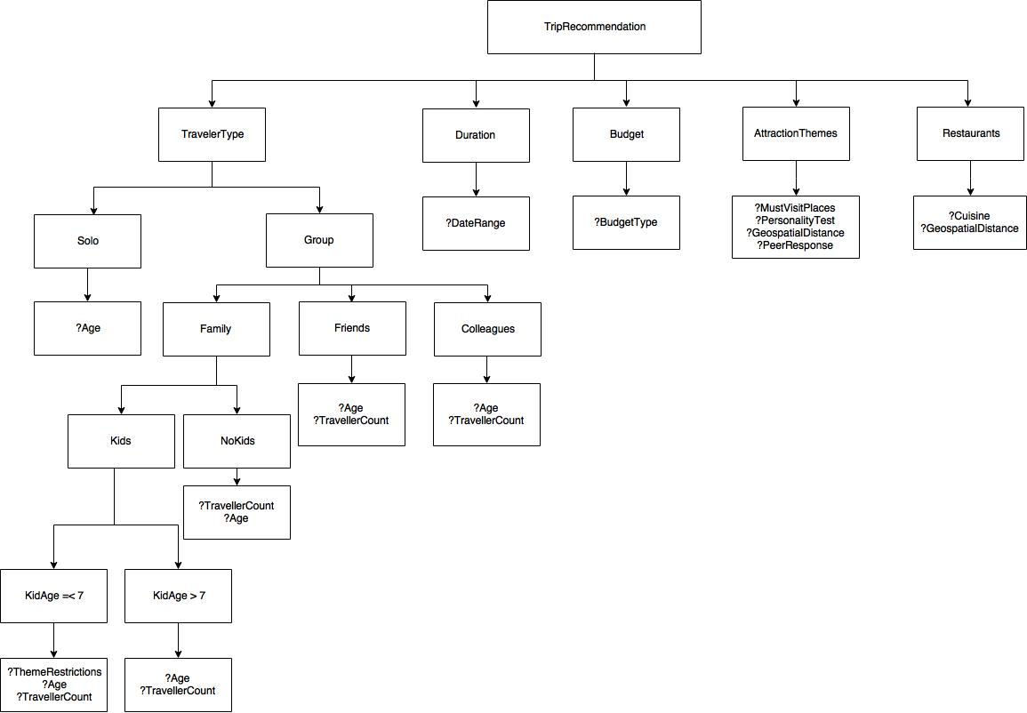

AI

**3.7@RULES**

We@generated@business@rules@from@the@surveys@conducted@using@association@mining@and@decision@tree.

A@summary@of@the@rule@base@structure@as@follows:

|  |  |  |  |  |  |  |  |
| --- | --- | --- | --- | --- | --- | --- | --- |
|  | **Rule@Category** |  |  | **Number@of@Rules@Generated** |  |  |  |
|  |  |  |  |  |  |  |  |
|  | **Total@Business@Rules@generated** | |  | |  |  |  |
|  | 214 | |  |  |  |
|  |  | |  | |  |  |  |
|  | **Theme@based@rules** | | 37 | |  |  |  |
|  |  | |  | |  |  |  |
|  | **Personality@based@rules** | | 81 | |  |  |  |
|  |  | |  | |  |  |  |
|  | **Ideal@#@of@places@based@rules** | | 16 | |  |  |  |
|  |  | |  | |  |  |  |
|  | **User@Input@based@rules** | | 20 | |  |  |  |
|  |  | |  | |  |  |  |
|  | **Rules@after@Optimization** | | 175 | |  |  |  |
|  |  |  |  |  |  |  |  |

AI



**4@SOLUTION@OUTLINE**



**4.1@SYSTEM@SCOPE**

Our@travel@recommender@system@is@built@using@the@**'python'@Language@Integrated@Production@System**@**(CLIPS)**.@It@being@a@recommendation@engine@enables@user@to@get@a@tailored@itinerary@of@the@places@to@visit**@**during@their@trip@in@India.@The@user’s@details,@and@trip@details@are@gathered@along@with@the@user@travel@persona,@which@helps@recommend@places@which@suits@their@taste.

This@helps@a@tourist@or@a@travel@agency@plan@better@trips.@Therefore,@can@do@more@than@a@normal@trip@recommendation@system@available@today,@which@requires@manual@effort.

**4.2@SYSTEM@ARCHITECTURE**

The@architecture@of@our@system@can@be@seen@in@the@diagram@below.

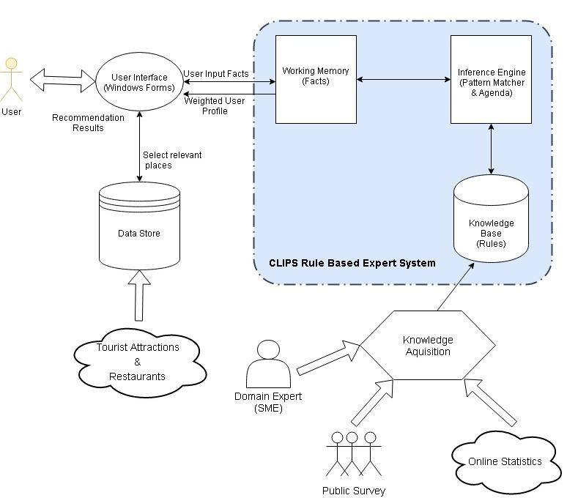

AI

The@knowledge@acquired@from@Domain@Expert,@Public@Surveys@and@Online@Statistics@have@been@used@to@create@rules@for@our@knowledge@base.@We@also@have@a@Data@Store,@which@has@information@about@tourist@attractions@and@restaurants@all@over@India.@This@information@has@been@collected@from@online@sources.@The@user@interacts@with@the@Windows@Forms@based@recommender@application.

The@CLIPS@shell@provides@basic@elements@of@the@expert@system@:-

Working@memory@:@Has@the@fact-list,@and@instance-list.@Is@the@global@memory@for@data

Knowledge-base:@Contains@all@the@rules,@the@rule-base

Inference@engine:@Controls@overall@execution@of@rules

The@facts@are@loaded@into@the@working@memory.@Based@on@the@user@inputs,@the@inference@engine@fires@the@rules.@In@our@system,@CLIPS@outputs@the@revised@weights@for@travel@themes.@The@Data@Store@is@used@to@generate@the@itinerary@based@on@these@weights@and@other@inputs@taken@from@the@user.

**4.3@INFERENCE@STRUCTURE@DIAGRAM**

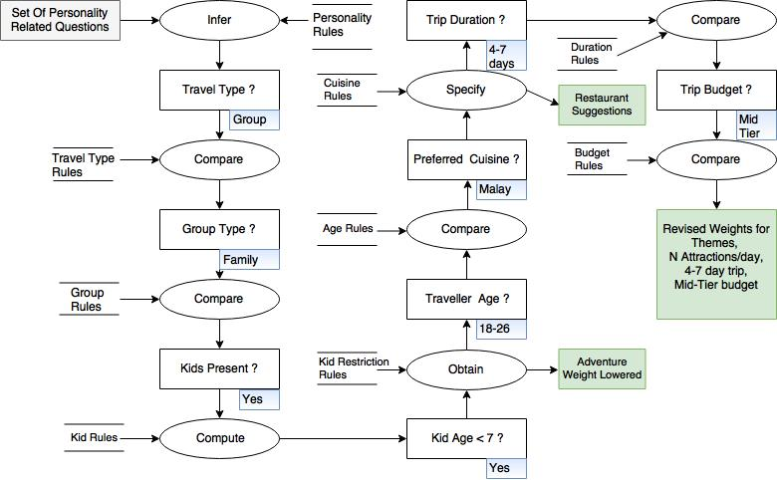Given@below@is@the@inference@structure@diagrams@:

4.3.1@Family@traveling@with@kids@below@7@years@of@age

In@this@case,@if@kids@below@7@years@of@age@are@travelling,@the@weight@of@adventure@theme@will@be@lowered.

AI

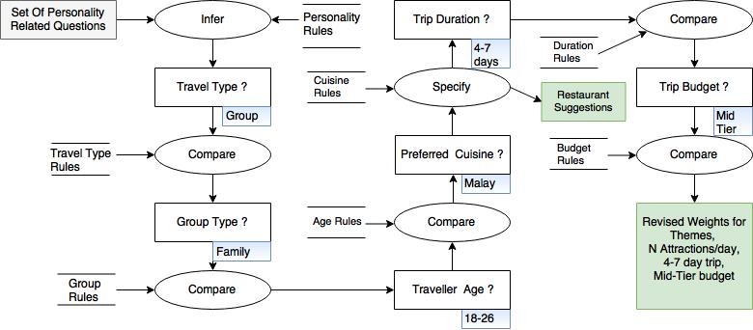

**4.4@SYSTEM@UNIQUENESS**

Our@system@has@a@number@of@unique@points@that@make@it@useful@in@the@travel@and@trip@planning@domain.@First,@it@has@an@adaptive@way@of@asking@questions@depending@on@the@user@input.@For@example,@if@the@traveler@type@is@family,@it@will@ask@whether@children@are@traveling@along@with@them@or@not.@This@won’t@be@asked@if@the@travel@group@is@solo,@friends@or@colleagues.

Our@system@doesn’t@just@give@what@places@to@visit,@it@will@present@the@user@with@an@itinerary@on@attraction@points@and@restaurants,@along@with@a@map@showing@the@route@to@these@places.@These@places@would@be@based@on@the@user@personality@which@had@been@analyzed@and@weighted@priority@wise@by@the@questionnaire@asked.

**4.5@SYSTEM@LIMITATIONS@&@ASSUMPTIONS**

The@travel@and@trip@planning@domain@is@very@vast@and@a@customized@trip@planner@takes@into@consideration@a@lot@of@factors@for@determining@what@kind@of@trip@is@best@suited@for@a@tourist@and@gives@him/her@the@best@experience.@Right@now,@our@system@doesn’t@handle@all@the@variables@required@such@that@it@can@accurately@customize@according@to@the@user@needs.@For@example,@we@don’t@do@end@to@end@trip@planning@for@the@customer.@Once@the@user@gets@to@India,@we@suggest@day@wise@itinerary@which@the@user@can@follow.@We@do@not@take@into@consideration@the@weather@or@traffic@conditions@for@the@itinerary.@We@assume@that@the@factors@such@as@flights,@accommodation@preferences@etc.@are@taken@care@of@by@the@user@himself.@Secondly,@the@scope@of@our@trip@planning@is@limited@to@India@for@this@project.@It@doesn’t@handle@the@planning@of@trips@worldwide.

AI



**5@CONCLUSION**



While@going@through@the@process@of@building@the@travel@recommender@expert@system,@we@came@to@know@about@how@the@various@factors@work@together@to@play@an@important@role@in@travel@planning.

The@system@can@be@improved@by@collecting@more@data@records@by@extending@surveys@to@various@sets@of@people@and@constructing@rules@dynamically@from@these@cases.@Additionally,@building@the@recommender@system@in@CLIPS@has@given@us@a@deeper@appreciation@of@rule-based@expert@systems,@particularly@their@advantages@and@limitations.

Of@course,@our@recommender@system@is@not@infallible,@and@there@are@always@further@improvements@to@be@made.@We@can@expand@the@system’s@scope@to@include@factors@considered@during@travel@such@as@accommodation@preference,@weather@conditions,@inclusion@of@nearby@events,@traffic@conditions@etc.@Also@we@can@extend@it@to@include@countries@other@than@India.

**5.1@REFRENCES**

ESDLC@approach@<https://www.slideshare.net/theintegralworm/esdlc>

STB@international@visitor@trend@<https://www.stb.gov.sg/statistics-and-market-insights/PublishingImages/IVA%20Oct%202017.jpg>

Tourism@trends@2018@<https://www.trekksoft.com/en/blog/65-travel-tourism-statistics-trends-for-2018#1>

India@Tourism@Board@Tourism@Statistics@<http://www.singstat.gov.sg/statistics/browse-by-theme/tourism>

Age@restrictions@for@theme@parks@[https://sg.theasianparent.com/universal-studios-India-ride-restrictions/](https://sg.theasianparent.com/universal-studios-singapore-ride-restrictions/)

Zomato@API@for@Restaurants@<https://developers.zomato.com/api>

Google@Maps@API@<https://developers.google.com/maps/>

<https://drgeraldstein.wordpress.com/2011/12/17/if-you-could-have-dinner-with-anyone-in-the-world/>

<https://www.psychologytoday.com/blog/mr-personality/200909/what-type-movie-person-are-you>

<https://www.yourtango.com/2015283635/what-your-dream-first-date-says-about-your-personality>

<https://www.psychologytoday.com/blog/the-love-wisdom/201409/kicking-the-bucket-list>

<http://www.businessinsider.com/what-these-popular-hobbies-and-interests-say-about-you-in-the-workplace-2012-7/?IR=T>

<https://kcallife.com/wellness-blog/a139/>

AI



**APPENDIX@A:@SAMPLE@INPUT@&@SYSTEM@OUTPUT**



**Case@1**

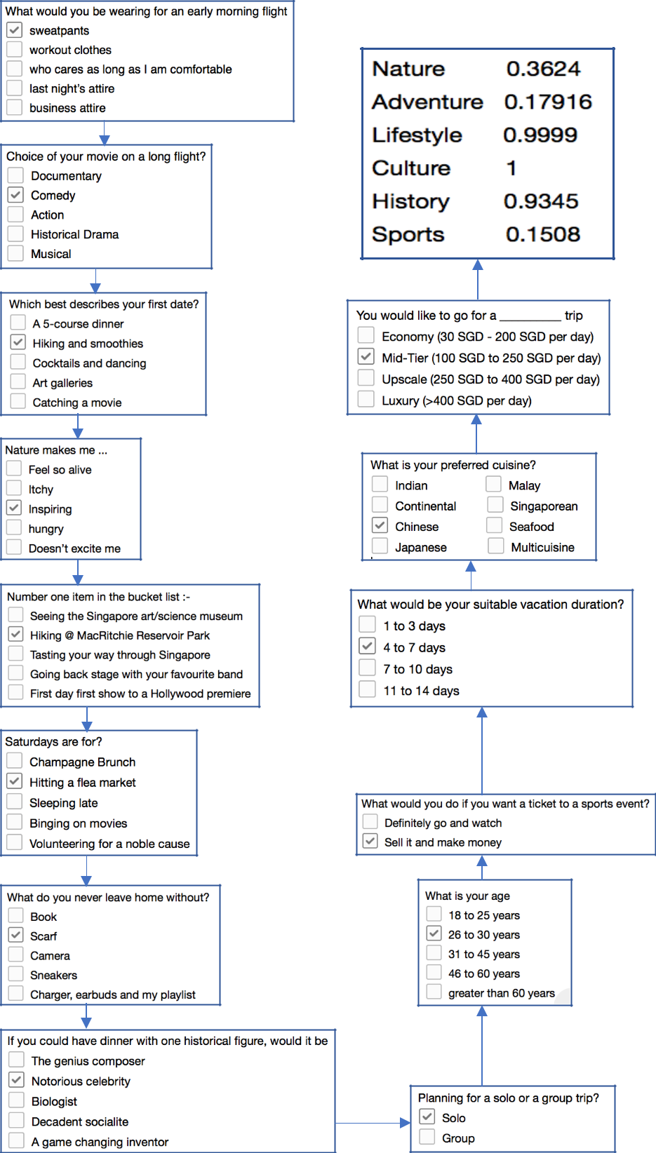

AI

**Case@2**

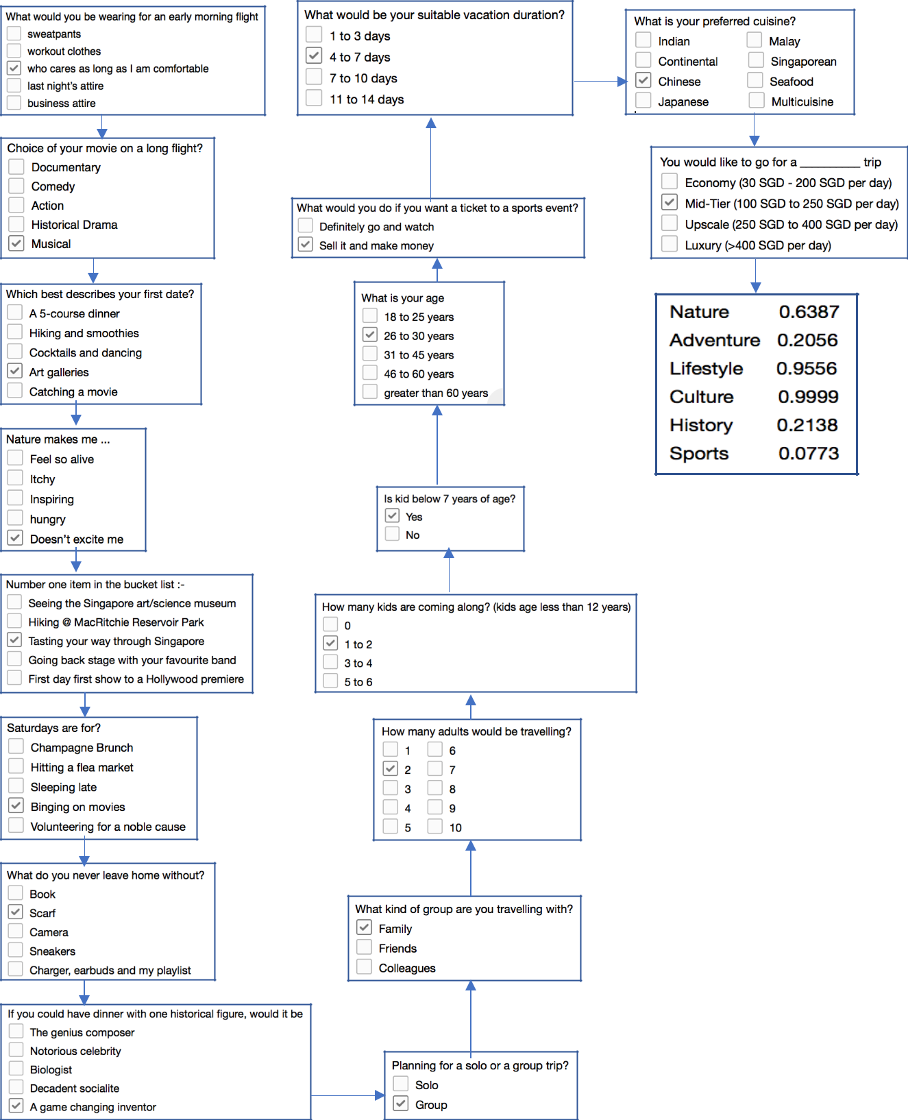

AI

**Case@3**

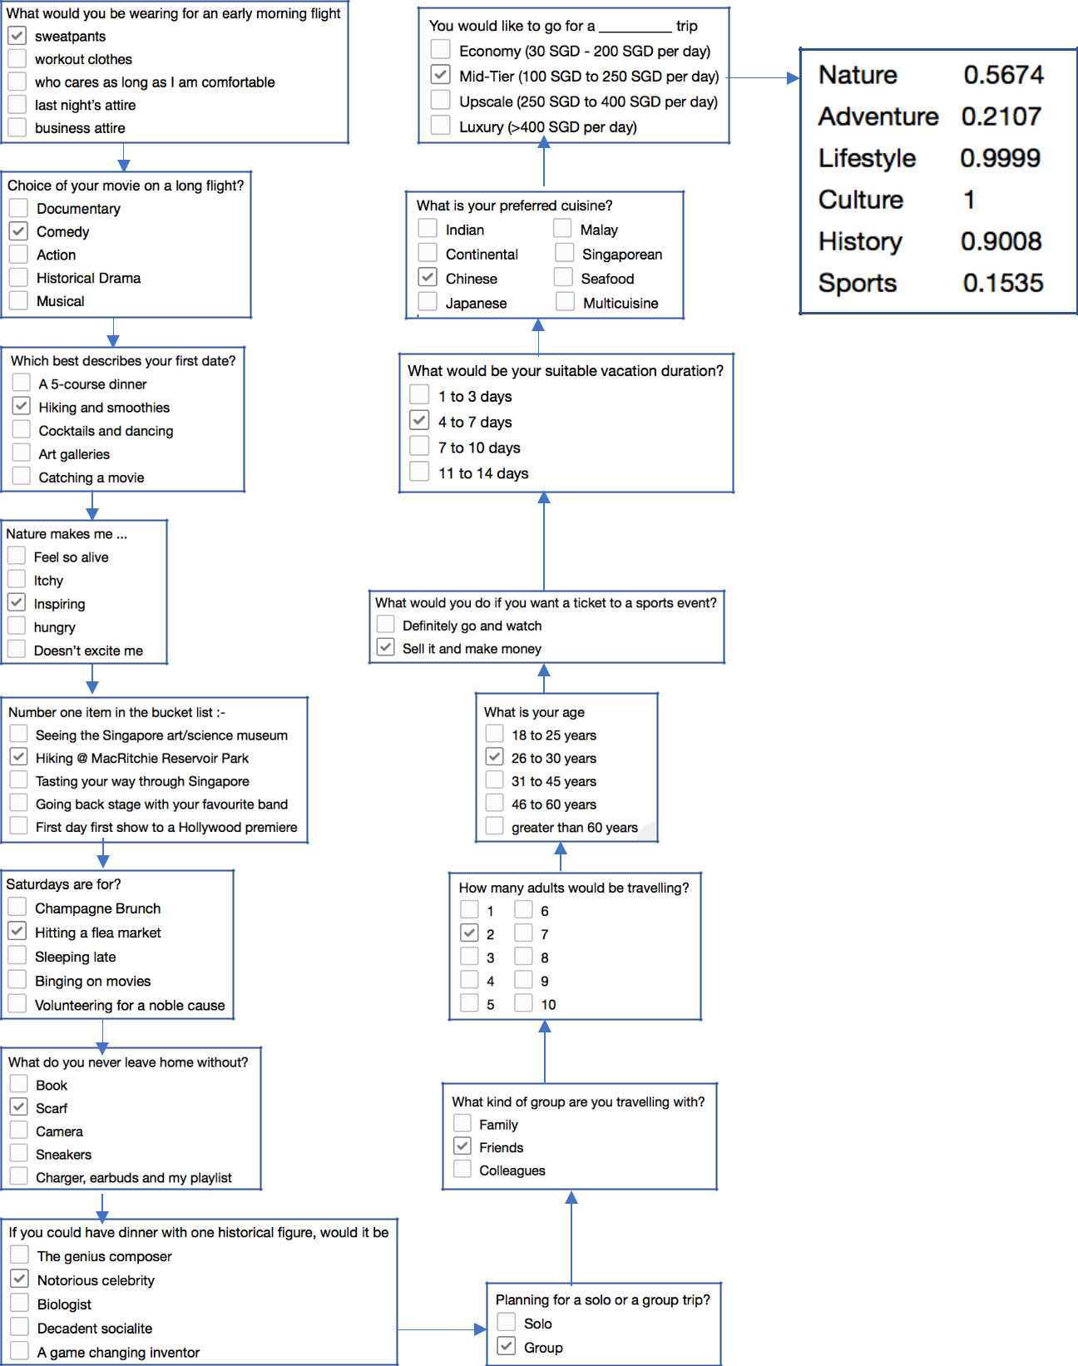

AI



**APPENDIX@B:@USERS@MANUAL**



**B.1@INSTALLING@TRIPPIER@–@THE@TRAVEL@RECOMMENDATION@VIRTUAL@ASSISTANT**

**SYSTEM@REQUIREMENTS**

This@system@is@supplied@with@a@compressed@zip@file@that@contains@the@following:

.NET@source@files

.NET@executable@files

CLIPS@DLL

Windows@forms@source@files

CLIPS@.NET@library@files

Resource@files@used@by@the@system

Image@files@used@by@the@system

Decompress@the@zip@file@to@the@“trippier”@folder.@This@folder@contains@all@the@above@mentioned@files.@The@system@is@already@compiled@into@an@executable@file@that@can@run@on@any@OS@platform.

**B.2@RUNNING@THE@SYSTEM**

In@the@“trippier”@folder,@double-click@the@self-executable@file@called@**Trippier.exe**.

If@successful,@users@will@be@first@greeted@by@the@Welcome@screen@of@the@system@as@shown@below.

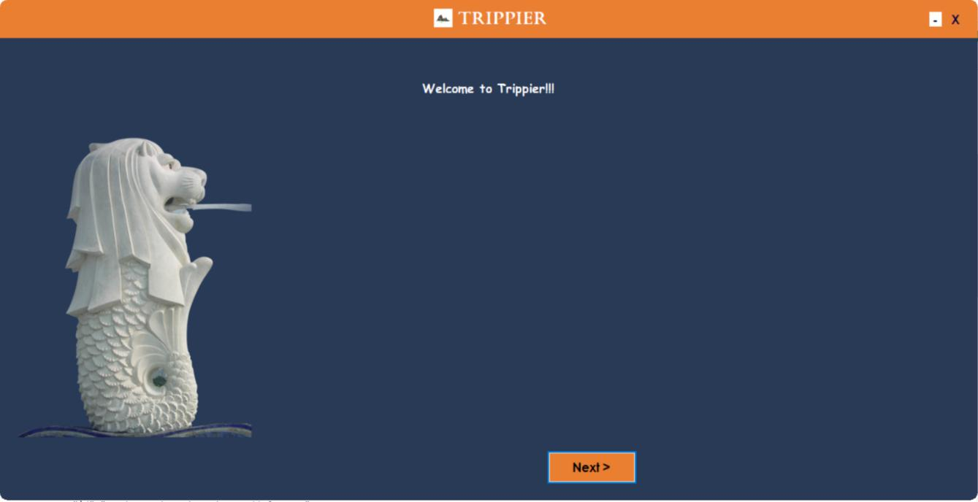

AI

**B.3@HOW@IT@WORKS**

**B.3.A@DYNAMIC@QUESTIONING**

Our@system@begins@with@a@set@of@questions,@related@to@trip@details@and@personality@of@the@user.

Click@“Next”@to@start@the@recommendation@system.@The@system@is@designed@to@do@dynamic@questioning@based@on@the@travel@group@type(solo/group@travel).@Based@on@the@option@selected,@it@asks@separate@sets@of@questions.@The@system@asks@the@whole@set@of@questions,@to@display@the@itinerary@at@the@end.

**B.3.B@RESPONSE@GATHERING**

A@question@may@be@answered@by@picking@an@option@from@a@given@set@of@choices.@The@UI@has@been@designed@in@a@way@that@minimizes@user@input.@This@has@been@done@to@provide@the@user@a@smooth@interaction@with@the@system.

The@figure@below@shows@the@widget@interface@for@one@of@the@questions@asked.

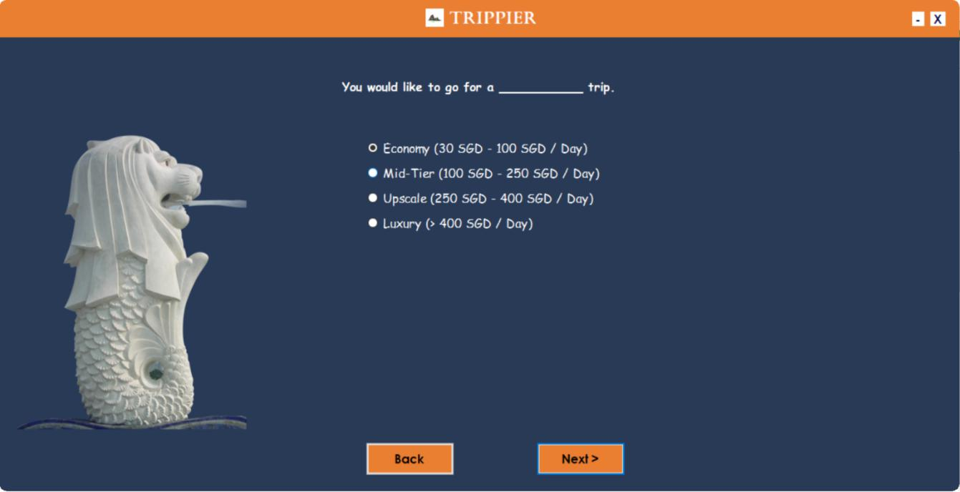

AI

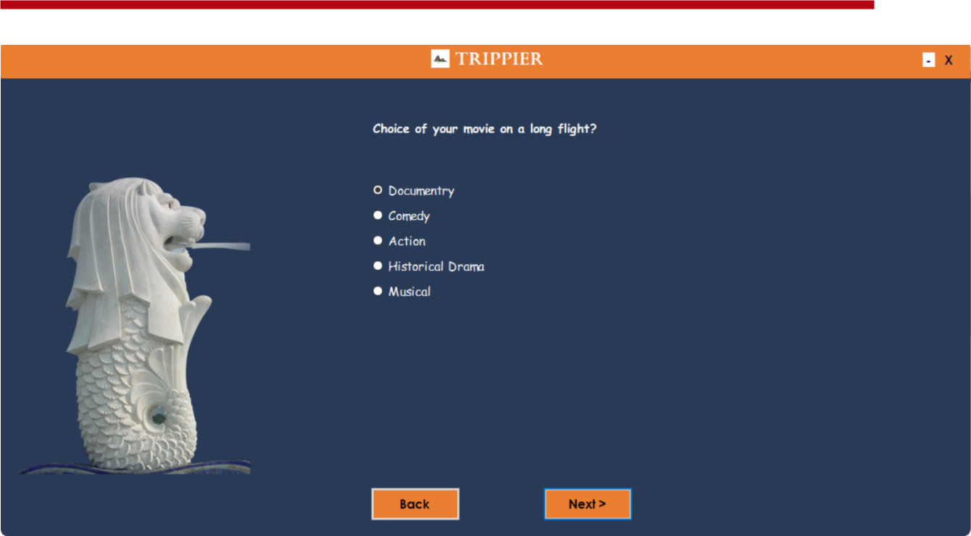

At@the@end@we@can@either@end@the@session@by@closing@the@application,@or@proceed@with@the@questions@again,@by@clicking@“Restart”.

**B.3@DISPLAYING@ITINERARY**

The@final@itinerary@is@displayed@as@the@following.@The@left@panel@displays@the@tourist@attractions@and@restaurants@under@the@**“Recommendations”**@window.@The@right@panel@shows@a@Google@map@route@connecting@these@places.@Additional@restaurant@information@(e.g.@rating)@is@also@provided@wherever@possible.@Also@as@it@is@an@itinerary@that@we@display@at@the@end,@a@drop@down@has@been@provided@at@top@left@corner@of@the@window@to@see@the@day@wise@itinerary.

